**CENTER FOR ARMY LESSONS LEARNED**

**BEFORE ACTION REPORT**

**Prepared for: (UNIT)**

**(NTC Rotation XX-XX)**

**Fort Irwin, CA**

**(Dates of Rotation)**

**TABLE OF CONTENTS**

* **Purpose**
* **NTC Observations**
* **After Action Report (AAR) Template**
* **CALL Services**
* **Popular CALL Publications for NTC Rotations**
  + **Top Three**
  + **CTC Trends and Observations**
  + **National Training Center (NTC) Specific**
  + **Home Station Training**
  + **Maneuver**
  + **Fires**
  + **Sustainment**
  + **Reconnaissance and Security**
  + **Intelligence**
  + **Cyber-Electromagnetic Activities (CEMA)**
  + **Medical**
  + **Leadership**
  + **Other Popular Publications**
* **Resource Links**

**PURPOSE**

The purpose of this report is to assist your organization with training in preparation of your NTC rotation. It includes all the releasable observations from past NTC Rotations describing how units could improve or sustain. Additionally, CALL resources have also been identified as the most popular and useful by previous units training at NTC. The intent is to share these identified resources early on in the training cycle for maximum effectiveness.

**After Action Report (AAR) Template**



**CALL Services** **(https://call2.army.mil)**

**After Action Reports**: AARs are sent to CALL to allow for further analysis and the ability to inform senior leaders and the force. Submit your unit’s AAR, find the recommended format, review the sample AAR and writing guide, or **browse the archive to learn from others**.

**Best Practices**: Share your unit or individual best practices with us and the rest of the Army! Learn more about the program and **view our recent submissions**.

**CTC Resources**: Find **observations**, **trends**, articles, training **videos**, and more from the CTC’s.

**[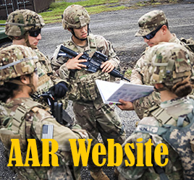](https://usacac.army.mil/organizations/mccoe/call) [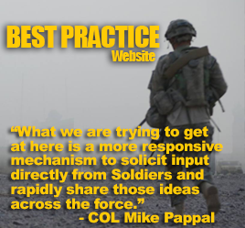](https://www.milsuite.mil/book/groups/ntc-operations-group) [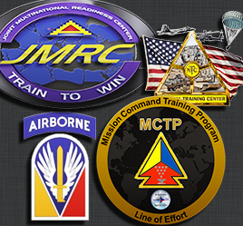](https://www.jllis.mil/apps/)**

**View and Submit AARs Best Practice Website CALL CTC Resources**

**[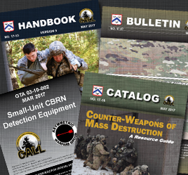](https://call2.army.mil/toc.aspx) [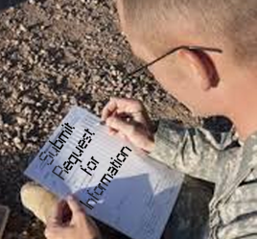](https://call2.army.mil/rfi) [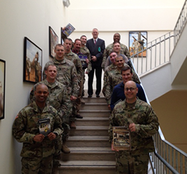](https://call2.army.mil/docs/doc2789/96-12BK.pdf)**

**Request for Publications Request for Information Lessons Learned Course**

**Request for Publications**: Click to **order CALL handbooks**, newsletters, etc. Items are shipped to unit address **free of charge**.

**Request for Information**: Have a question? Need help fast? Send a **request for information**! CALL staff will do the research and **provide a response** with relevant products (if applicable).

**Lessons Learned Course**: View dates available to send personnel to the course.

**CALL Publications**

**TOP THREE**

**[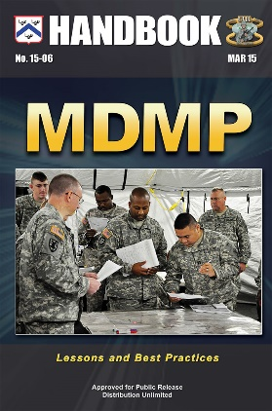](https://call2.army.mil/toc.aspx?document=7288&filename=/docs/doc7288/15-06.pdf) [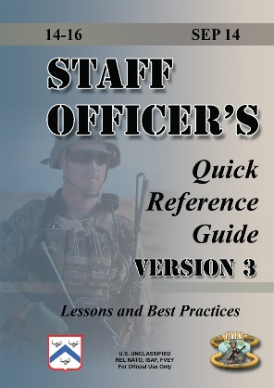](https://call2.army.mil/toc.aspx?document=7279&filename=/docs/doc7279/14-16%20Staff%20Officer's%20Quick%20Reference%20Guide,%20Version%203.pdf) [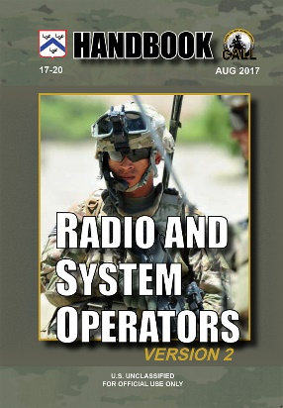](https://call2.army.mil/aar/default.aspx?document=17531&filename=/docs/doc17531/17-20.pdf)**

**15-06: MDMP Lessons and Best Practices Handbook**

<https://call2.army.mil/toc.aspx?document=7288>

**14-16: Staff Officer’s Quick Reference Guide Version III**

<https://call2.army.mil/toc.aspx?document=7279>

**17-20: Radio and System Operators Handbook**

<https://call2.army.mil/toc.aspx?document=17531>

**GENERAL CTC TRENDS AND OBSERVATIONS**

**[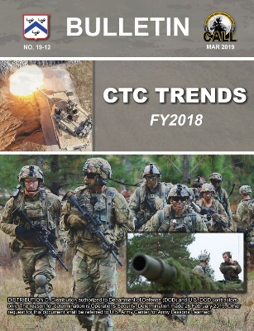](https://call2.army.mil/toc.aspx?document=17836&filename=/docs/doc17836/19-12.pdf) [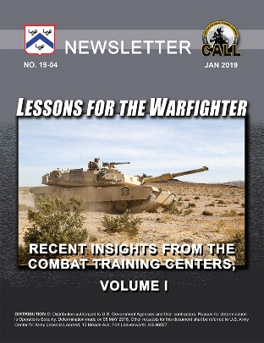](https://call2.army.mil/bp/Default.aspx?document=17814&filename=/docs/doc17814/19-04.pdf) [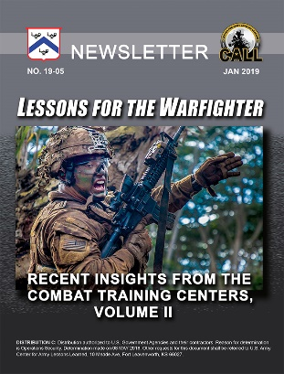](https://call2.army.mil/ctc/ctc_resources.aspx?document=17815&filename=/docs/doc17815/19-05.pdf)**

**19-12: CTC Trends (FY 2019)**

<https://call2.army.mil/toc.aspx?document=17836>

**19-04: Lessons for the Warfighter I**

[https://call2.army.mil/toc.aspx?document=17814](https://call2.army.mil/docs/doc7445/GTA_03-08-002.pdf?document=17814)

**19-05: Lessons for the Warfighter II**

<https://call2.army.mil/toc.aspx?document=17815>

**NATIONAL TRAINING CENTER SPECIFIC**

**[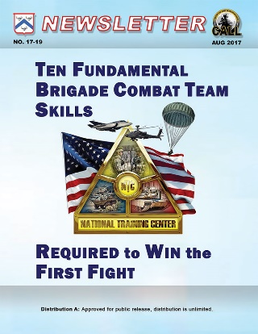](https://call2.army.mil/toc.aspx?document=17526&filename=/docs/doc17526/17-19.pdf)** [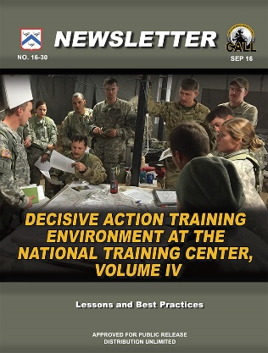](https://call2.army.mil/rfp/default.aspx?document=7413&filename=/docs/doc7413/16-30.pdf) **[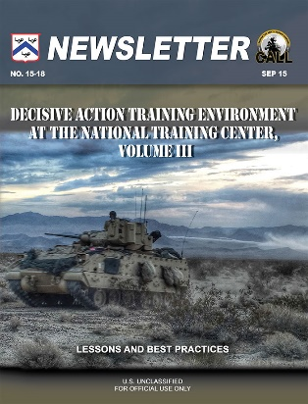](https://call2.army.mil/toc.aspx?document=7316&filename=/docs/doc7316/15-18.pdf)**

**17-19: Ten Fundamental BCT Skills Required to Win the First Fight**

[https://call2.army.mil/toc.aspx?document=17526](https://call2.army.mil/docs/doc2789/96-12BK.pdf?document=17526)

**16-30: DATE at the NTC Vol IV**

<https://call2.army.mil/toc.aspx?document=7413>

**15-18: DATE at the NTC Vol III**

<https://call2.army.mil/toc.aspx?document=7316>

**HOME STATION TRAINING**

**[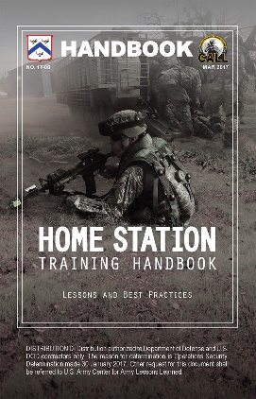](https://call2.army.mil/toc.aspx) [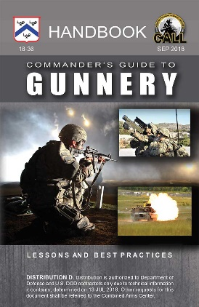](https://call2.army.mil/docs/doc17781/17781.pdf)** [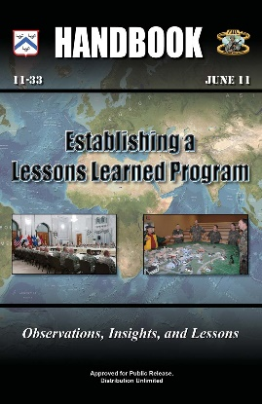](https://call2.army.mil/ctc/ctc_resources.aspx)

**17-08: Home Station Training Handbook**

[https://call2.army.mil/toc.aspx?document=7471](https://www.jllis.mil)

**18-36: Commander’s Guide to Gunnery Handbook**

<https://call2.army.mil/toc.aspx?document=17781>

**11-33: Establishing a Lessons Learned Program**

[https://call2.army.mil/docs/doc6625/11-33.pdf](https://call2.army.mil/ll-course.aspx)

**MANEUVER**

**[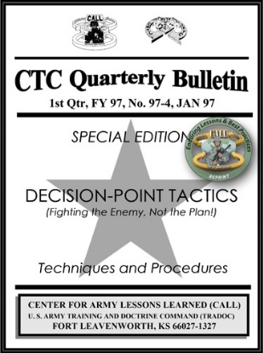](https://call2.army.mil/toc.aspx) [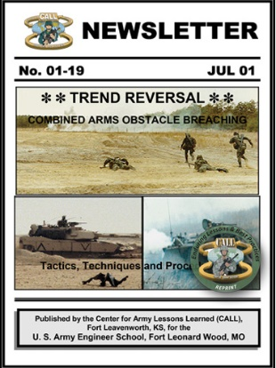](https://call2.army.mil/docs/doc348/01-19bk.pdf)** [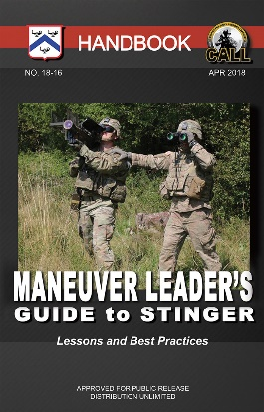](https://call2.army.mil/docs/doc6625/11-33.pdf?document=17649&filename=/docs/doc17649/18-16.pdf)

**97-4: Decision-Point Tactics**

[https://call2.army.mil/docs/doc2392/97-4.pdf#page=1](https://call2.army.mil/toc.aspx#page=1)

**01-19: Combined Arms Obstacle Breaching**

[https://call2.army.mil/docs/doc348/01-19bk.pdf#page=1](https://call2.army.mil/toc.aspx#page=1)

**18-16: Maneuver Leader’s Guide to Stinger**

[https://call2.army.mil/toc.aspx?document=17649](https://call2.army.mil/docs/doc17658/18-24.pdf?document=17649)

**FIRES**

**[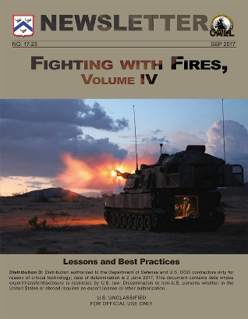](https://call2.army.mil/toc.aspx?document=17543&filename=/docs/doc17543/17543.PDF)**  [](https://call2.army.mil/toc.aspx?document=7059&filename=/docs/doc7059/13-07.pdf) [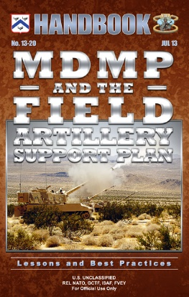](https://call2.army.mil/toc.aspx?document=7097&filename=/docs/doc7097/13-20.pdf)

**17-23: Fighting with Fires, Volume IV**

<https://call2.army.mil/toc.aspx?document=17543>

**13-07: Fires Rehearsals**

<https://call2.army.mil/toc.aspx?document=7059>

**13-20: MDMP and the Field Artillery Support Plan**

[https://call2.army.mil/docs/doc7097/13-20.pdf](https://call2.army.mil/docs/doc7471/7471.pdf)

**SUSTAINMENT**

[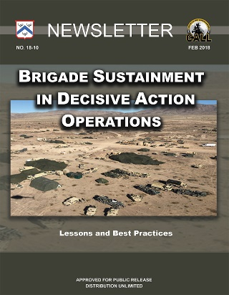](https://call2.army.mil/docs/doc6625/11-33.pdf?document=17611&filename=/docs/doc17611/17611.pdf) [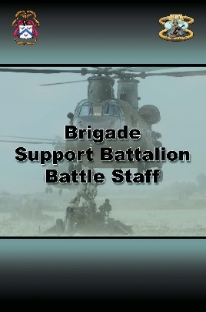](https://call2.army.mil/toc.aspx) [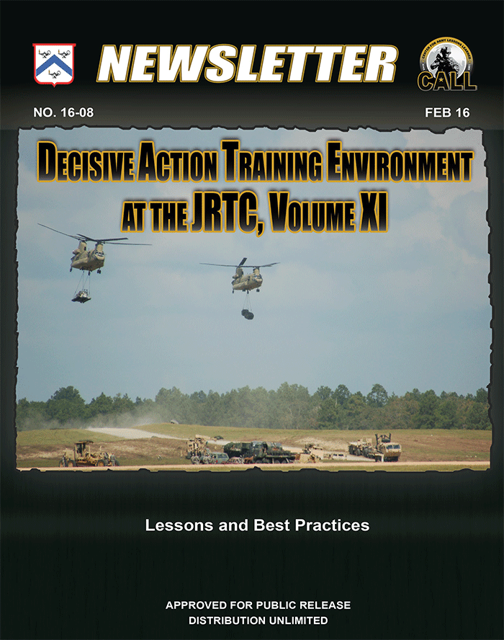](https://call2.army.mil/toc.aspx#page=1)

**18-10: Brigade Sustainment in Decisive Action Operations**

<https://call2.army.mil/toc.aspx?document=17611>

**08-23: Brigade Support Battle Staff**

https://call2.army.mil/toc.aspx?document=4215

**16-08: Decisive Action Training Environment at the JRTC, Sustainment**

<https://call2.army.mil/toc.aspx?document=7353>

**RECONNAISSANCE AND SECURITY**

[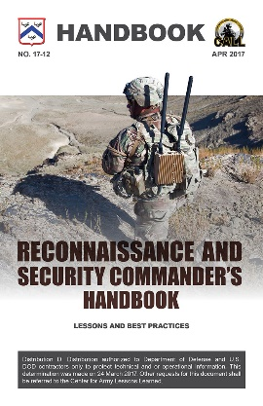](https://call2.army.mil/toc.aspx?document=7482&filename=/docs/doc7482/17-12_26APR.pdf) [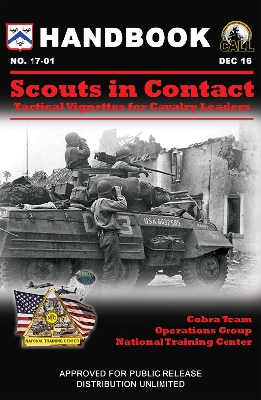](https://call2.army.mil/toc.aspx?document=7430&filename=/docs/doc7430/17-01.pdf) [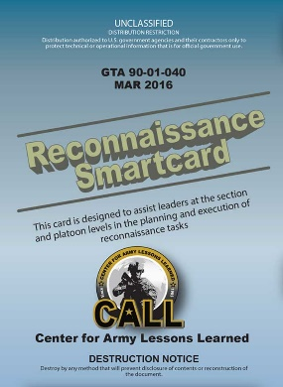](https://call2.army.mil/docs/doc348/01-19bk.pdf)

**17-12: Reconnaissance and Security Commander’s Handbook**

<https://call2.army.mil/toc.aspx?document=7482>

**17-01: Scouts in Contact**

<https://call2.army.mil/toc.aspx?document=7430>

**GTA 90-01-040: Reconnaissance Smartcard**

<https://call2.army.mil/toc.aspx?document=7357>

**INTELLIGENCE**

**[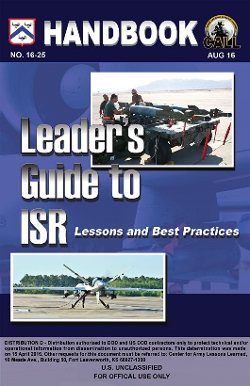](https://call2.army.mil/toc.aspx?document=7406&filename=/docs/doc7406/16-25.pdf) [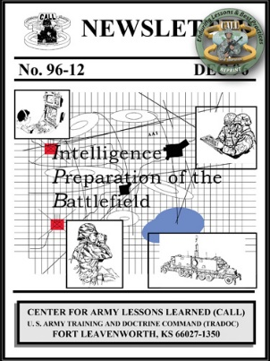](https://call2.army.mil/toc.aspx)** [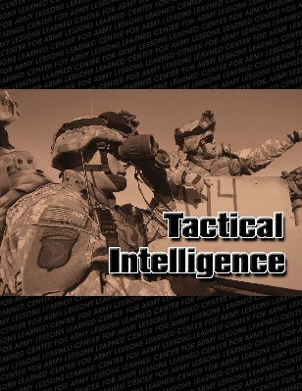](https://call2.army.mil/toc.aspx)

**16-25: Leaders Guide to ISR Handbook**

[https://call2.army.mil/toc.aspx?document=7406](https://call2.army.mil/docs/doc4215/08-23.pdf?document=7406)

**96-12: Intelligence Preparation of the Battlefield**

[https://call2.army.mil/docs/doc2789/96-12BK.pdf#page=1](https://call2.army.mil/toc.aspx#page=1)

**07-01: Tactical Intelligence**

[https://call2.army.mil/toc.aspx?document=163](https://call2.army.mil/docs/doc7353/16-08.pdf?document=163)

**CYBER-ELECTROMAGNETIC ACTIVITIES (CEMA)**

**[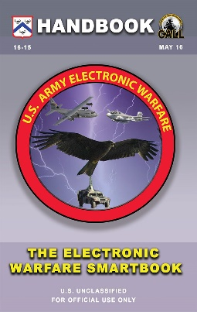](https://call2.army.mil/toc.aspx?document=7383&filename=/docs/doc7383/16-15.pdf) [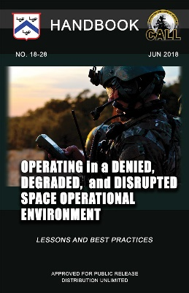](https://call2.army.mil/toc.aspx?document=17729&filename=/docs/doc17729/18-28.pdf) [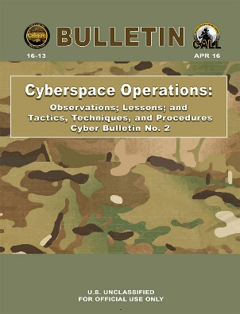](https://call2.army.mil/toc.aspx)**

**16-15: The Electronic Warfare Smartbook**

[https://call2.army.mil/toc.aspx?document=7383](https://call2.army.mil/docs/doc2392/97-4.pdf?document=7383)

**18-28: Operating in a Denied, Degraded, and Disrupted Space Operational Environment**

[https://call2.army.mil/toc.aspx?document=17729](https://call2.army.mil/docs/doc7357/GTA90-01-040.pdf?document=17729)

**16-13: Cyberspace Operations**

<https://call2.army.mil/toc.aspx?document=7375>

**MEDICAL**

[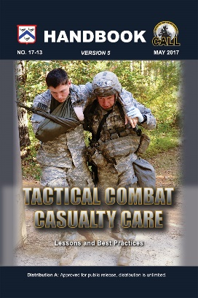](https://call2.army.mil/docs/doc7375/16-13.pdf?document=17493&filename=/docs/doc17493/17493.pdf)[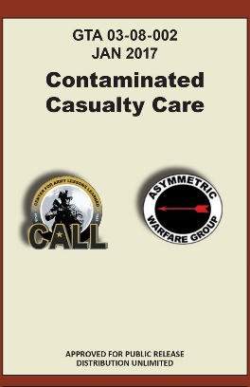](https://call2.army.mil/toc.aspx)[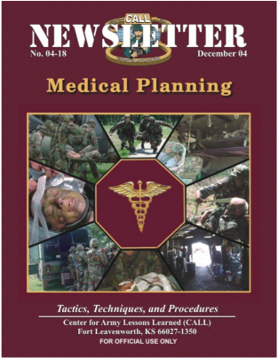](https://call2.army.mil/toc.aspx?document=226)

**17-13: Tactical Casualty Combat Care**

<https://call2.army.mil/toc.aspx?document=17493>

**GTA 03-08-002: Contaminated Casualty Care**

[https://call2.army.mil/toc.aspx?document=7445](https://call2.army.mil/docs/doc163/07-01.pdf?document=7445)

**04-18: Medical Planning Tactics, Techniques, and Procedures**

[https://call2.army.mil/toc.aspx?document=226](https://call2.army.mil/docs/doc7097/13-20.pdf?document=226)

**LEADERSHIP**

**[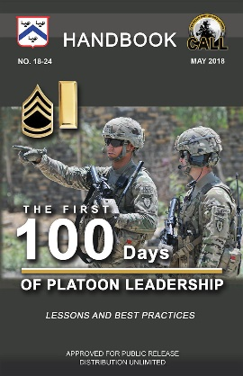](https://call2.army.mil/toc.aspx) [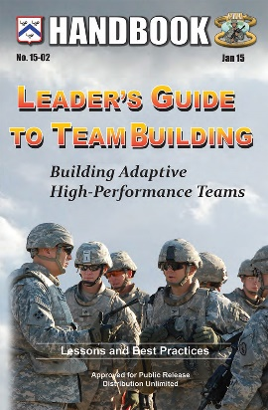](https://call2.army.mil/toc.aspx?document=7282&filename=/docs/doc7282/15-02.pdf) [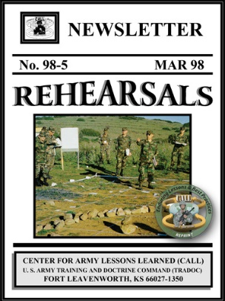](https://call2.army.mil/toc.aspx)**

**18-24: The First 100 Days of Platoon Leadership Handbook**

<https://call2.army.mil/toc.aspx?document=17658>

**15-02: Leaders Guide to Team Building**

<https://call2.army.mil/toc.aspx?document=7282>

**98-5: Rehearsals**

[https://call2.army.mil/docs/doc2739/98-5BK.pdf#page=1](https://call2.army.mil/docs/doc2392/97-4.pdf#page=1)

**OTHER POPULAR PUBLICATIONS**

**[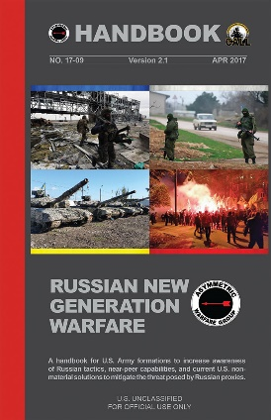](https://call2.army.mil/toc.aspx) [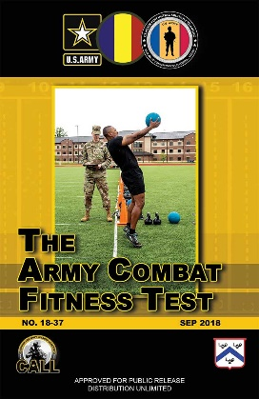](https://call2.army.mil/toc.aspx?document=17784&filename=/docs/doc17784/17784.pdf) [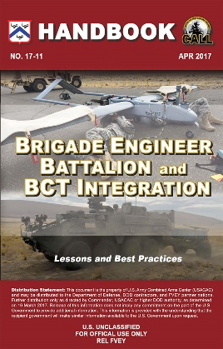](https://call2.army.mil/toc.aspx?document=7480&filename=/docs/doc7480/17-11.pdf)**

[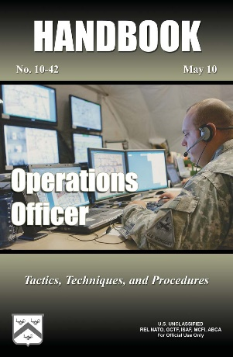](https://call2.army.mil/docs/doc6008/10-42.pdf)[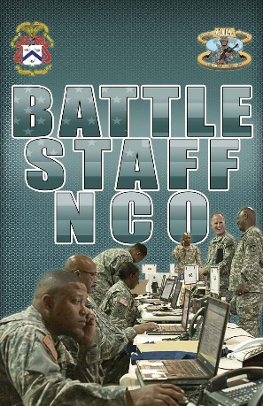](https://call2.army.mil/docs/doc4134/08-15.pdf)[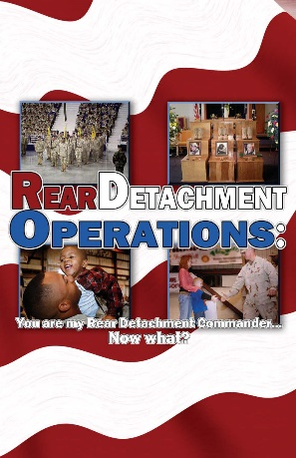](https://call2.army.mil/toc.aspx?document=2906)

**17-09: Russian New Generation Warfare Handbook**

<https://call2.army.mil/toc.aspx?document=7434>

**18-37: The Army Combat Fitness Test**

<https://call2.army.mil/toc.aspx?document=17784>

**17-11: Brigade Engineer Battalion and BCT Integration**

<https://call2.army.mil/toc.aspx?document=7480>

**10-42: Operations Officer Handbook**

<https://call2.army.mil/toc.aspx?document=6008>

**08-15: Battle Staff NCO Handbook**

[https://call2.army.mil/toc.aspx?document=4134](https://call2.army.mil/docs/doc2739/98-5BK.pdf?document=4134)

**07-23: Rear Detachment Operations**

<https://call2.army.mil/toc.aspx?document=2906>

**RESOURCE LINKS**

**Center for Army Lessons Learned (CALL) Restricted Website**

Primary CALL website offering CALL resources (Publications, Best practices, RFIs, etc.)

<https://call2.army.mil>

**Center for Army Lessons Learned (CALL) Public Website**

Public website as part of the Combined Arms Center offering information approved for public release.

[https://usacac.army.mil/organizations/mccoe/call](https://call2.army.mil/toc.aspx)

**Center for Army Lessons Learned Combat Training Center Resources Website:**

Includes resources (observations, videos, CTC products, CTC articles) from NTC, JRTC, JMRC, and MCTP.

[https://call2.army.mil/ctc/ctc_resources.aspx](https://call2.army.mil/docs/doc2739/98-5BK.pdf)

**National Training Center (NTC) Operations Group MilSuite Website**

Includes resources (training videos, articles, observations, etc.) coming straight from the NTC

[https://www.milsuite.mil/book/groups/ntc-operations-group](https://call2.army.mil/docs/doc7434/17-09_RNGW_V2.1.pdf)

**Joint Lessons Learned Information System (JLLIS)**

The DOD system of record for AARs, Lessons Learned, and Best Practices by providing all users a single, integrated system for the input, collection, analysis, dissemination, integration and archiving of lessons.

[https://www.jllis.mil](https://call2.army.mil/toc.aspx)

**NTC Lessons Learned Binder (Joint Lessons Learned Information System - JLLIS):** Includes all releasable observations and products related to NTC on JLLIS

[https://www.jllis.mil/apps/?binderid=10273&do=binders:binder.summary](https://call2.army.mil/toc.aspx?binderid=10273&do=binders:binder.summary)